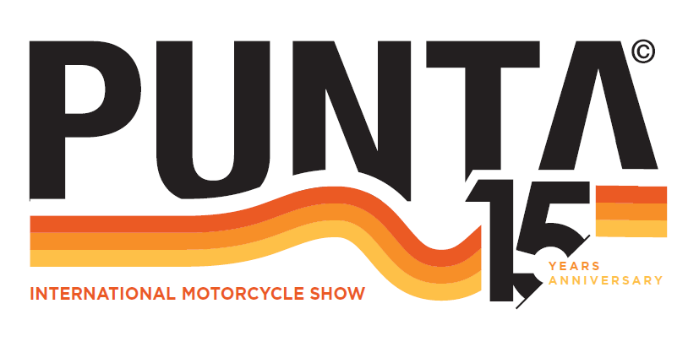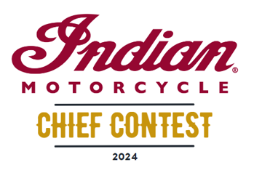

Rules for the customisation competition
INDIAN CHIEF CONTEST

Article 1: Presentation
The Indian Chief Contest is an event organized by Indian Motorcycle taking place as part of the Punta Courchevel 2024 event. The objective is to highlight the creativity and customization talent of the participants.
Article 2: Eligible models
The following models are eligible for the competition:
- Indian Chief
- Indian Sportchief
- Indian Superchief
- Indian Chief Bobber
Article 3: Conditions of participation
3.1. The motorcycles presented must be rolling and in working order to be able to make the descent to the Alpinium and the ascent to the Altiport during the event on Saturday July 6, 2024.
3.2. Motorcycles entered into the competition will be on display at the Indian Motorcycle stand, opposite the Roadshow testing facility.

Article 4: Eligible participants
The following are authorized to participate in the competition:
- Indian Motorcycle dealers in the following countries: France, Switzerland, Germany, Belgium, Italy, Spain, Portugal.
- Indian Motorcycle customers.
- Motorcycle preparers.
Article 5: Categories
The competition is divided into three distinct categories:
- Street Legal: only approved parts that comply with regulations and painting are authorised.
- Customers: open to the Indian Motorcycle’s customers, this category highlights the personalisation carried out by amateurs.
- Open: Reserved for preparers and dealers, this category allows total freedom of customisation.
Article 6: Judgment criteria
Motorcycles will be evaluated according to the following criteria:
- Originality and creativity of customisation.
- Quality of execution of modifications.
- General aesthetics and design consistency.
- Compliance with security rules for the Street Legal category.
Article 7: Registrations
7.1. Registrations will be open until June 15, 2024. To register, the participant must sign these regulations at the bottom of the document and return it to the following email address: indianchiefcontest@gmail.com
7.2. Each participant will need to complete a form including the details of the motorcycle and the modifications made (the form will be sent after registration).

Article 8: Prizes
Prizes will be awarded to the winners in each category:
- Street Legal: vouchers to spend on Indian Motorcycle parts/accessories/equipment at an official Indian Motorcycle dealership
1st Prize = 500€ inc. tax 2nd Prize = 300€ inc. tax 3rd Prize = 100€ inc. tax
- Customers: vouchers to spend on Indian Motorcycle parts/accessories/equipment at an official Indian Motorcycle dealership
1st Prize = 500€ inc. tax 2nd Prize = 300€ inc. tax 3rd Prize = 100€ inc. tax
- Open :
1st Prize = a 200L drum of Indian Motorcycle oil
2nd Prize = a 60L drum of Indian Motorcycle oil
3rd Prize = 12 cans of 1L of Indian Motorcycle oil
Article 9: General provisions
9.1. The organisers reserves the right to disqualify any motorcycle that does not meet the participation criteria or any conduct contrary to the ethics of the event.
9.2. Participants are responsible for ensuring that their motorcycle complies with local safety and approval regulations.
9.3. Participants authorise the use of photographs of their motorcycle for promotional purposes by Indian Motorcycle and Punta Courchevel.
Article 10: Acceptance of The Rules
Participation in the competition implies full acceptance of these regulations.

I the undersigned ......................................................................... hereby accepts the conditions of participation in the INDIAN CHIEF CONTEST organised by INDIAN MOTORCYCLE during PUNTA COURCHEVEL 2024
Date :

Signature (preceded by the words “Read and approved”)

